Section B
Answer two of the three questions in this section on separate paper

1 | (a) | An organic compound A has the following composition by mass: C, 35.0%; H, 6.6%; Br, 58.4%. It has a relative molecular mass of 136.9. Determine the chemical formula of A.  C H Br  % by mass 35.0 6.6 58.4  No. of moles 35/12 = 2.92 6.6 0.731  Smallest ratio 4 9 1  E.F. = C₄H₉Br  M.F. = C₄H₉Br | [2]
 | (b) | Heating A under reflux with aqueous NaOH gives a compound B and heating B with an excess of acidified K₂Cr₂O₇ gives a compound C.  When 2,4-dinitrophenylhydrazine reagent is added to C, an orange precipitate D was produced. C did not give a silver mirror with Tollen’s reagent but it produced a yellow precipitate and an organic compound E when reacted with aqueous alkaline iodine.  Heating A under reflux with ethanolic NaCN gives compound F.  Heating B under reflux with concentrated H₂SO₄ gives three isomeric products, G, H and I, which decolourise aqueous bromine.  Draw the structures A to I and explain the reactions.  Deductions:  Heating A with NaOH to give B B is an alcohol (or 1º or 2º alcohol)  Heating B with K₂Cr₂O₇ gives C C is either a ketone or an acid  C reacts with 2,4-DNPH to give D C is a ketone or aldehyde  C does not react with Tollen’s C is a ketone (Or C is not an aldehyde)  C reacts with aqueous alkaline I₂ to give yellow crystals and E  C has this structure: CH₃-C=O  E is a salt of an acid  (not accepted if students write only this structure: CH₃-C-OH as previously it was deduced that it is a ketone)  Heating A under reflux with ethanolic NaCN gives F nucleophilic substitution, F is a nitrile  Heating A with concentrated H₂SO₄ gives 3 products elimination reaction. H₂O is removed. G, H and I are alkenes  Structures:  A: CH₃CH(Br)CH₂CH₃  B: CH₃CH(OH)CH₂CH₃  C: CH₃COCH₂CH₃  D:  E: CH₃CH₂COO⁻  F: CH₃CH(CN)CH₂CH₃  G:  H:  I: | [15]
 | (b) | Arrange the following in order of increasing boiling points and explain your reasoning in terms of bonding and structure.  CH₃CH(C₂H₅)C₃H₇ CH₃CH₂C(CH₃)₂CH₃ CH₃(CH₂)₅CH₃  CH₃CH₂C(CH₃)₂CH₃ CH₃CH(C₂H₅)C₃H₇ CH₃(CH₂)₅CH₃  (1) (2) (3)  (1) has a smaller electron cloud than (2) and (3) and hence has a weaker id-id intermolecular forces of attraction. OR (1) has a smaller carbon number.  (2) and (3) are isomers, but (2) is a branched structure and (3) is a straight chain.  (2) has a smaller surface area of contact between molecules than (3), hence has weaker id-id intermolecular forces of attraction. Therefore, lesser energy needed to overcome weaker id-id. | [3]

2 | (a) | Sodium and phosphorus react with chlorine to form NaCl and PCl₃ respectively.
 |  | (i) | Describe the chemical reaction, if any, of the two chlorides with water. Suggest the colour of methyl orange when it is added separately to each of the solutions.  NaCl undergoes hydration to form ions through ion-dipole interaction. Methyl orange turns yellow when added to this solution.  PCl₃ undergoes hydrolysis to form acidic solution. Methyl orange turns red. | [4]
 |  | (ii) | Explain, with the aid of appropriate equations, the difference in the colour of the indicator in these solutions.  NaCl(s) + aq → Na⁺(aq) + Cl⁻(aq)  The hydrated Na⁺ has low charge density, it does not hydrolysed in water, thus pH remains at 7.  PCl₃(s) + 3H₂O → H₃PO₃(aq) + 3HCl(aq)  PCl₃ undergoes hydrolysis to form acidic solution. | [3]
 | (b) | Phosphorous trichloride and chlorine react to form phosphorous pentachloride gas in the equation shown below:  PCl₃(g) + Cl₂(g) PCl₅(g)
 |  | (i) | Write an expression for K_{c} for this reaction, giving its units. | [2]
 |  | (ii) | An equilibrium mixture in a 2 dm³ vessel is found to contain 0.0406 mol PCl₃, 0.170 mol Cl₂ and 0.302 mol PCl₅ at 450 K. Calculate the K_{c} at this temperature. | [1]
 |  | (iii) | Describe and explain what would happen to the concentration of PCl₅ if  I more chlorine is added to the reaction vessel  II the size of the reaction vessel is reduced to 1 dm³  I When more chlorine is added, the position of the equilibrium will shift to the right, increasing the concentration of PCl₅  II When the pressure is increased, the position of equilibrium will shift to the right, increasing the concentration of PCl₅. | [2]
 |  | (iv) | Using the Maxwell-Boltzmann Distribution curve, explain what would happen to the rate of the forward reaction if the reaction is carried out at 500 K.  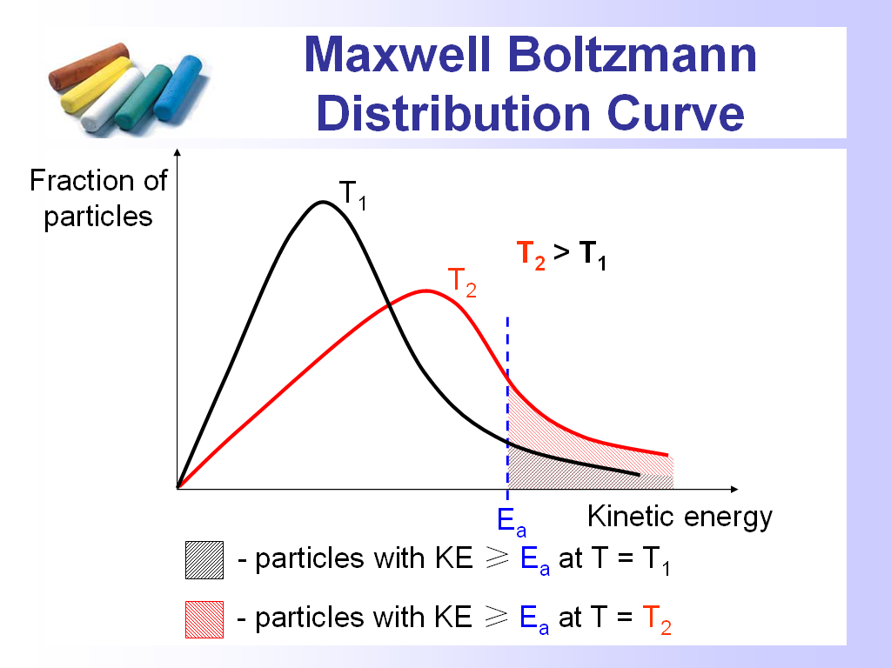  As temperature increase, the peak moves to the right. There is an increase in the number of particles with kinetic energy ≥ E(1)_{a}. As a result, the frequency of effective collision increases(1), resulting in an increase in the rate of the forward reaction. | [3]
 | (c) | 2-chlorobutane can react with hydroxide ions under two different sets of reaction conditions to give two different products.
 |  | (i) | Describe the conditions necessary for each of the reactions I and II.  I Heat with alcoholic OH⁻  II Heat with aqueous OH⁻ | [2]
 |  | (ii) | Describe the observations when 2-chlorobutane is heated with ethanolic AgNO₃(aq).  White ppt observed.
 |  | (iii) | Using the Data Booklet, describe and explain, the observations when 2-iodobutane is used for the reaction in (ii).  Yellow ppt is observed within a shorter time. The substitution requires the breaking of the C-X bond. C-I having a lower bond energy than C-Cl, will result in a faster precipitation.
 |  |  |  | [3]
3 |  | Blood plasma is a biological fluid that plays an important role in maintaining pH in the body.  In the blood plasma, the equilibrium between carbonic acid, H₂CO₃(aq), and hydrogencarbonate ion, HCO₃⁻(aq), buffers pH changes.  H₂CO₃(aq) H⁺(aq) + HCO₃⁻(aq)  The K_{a} for this equilibrium is 7.90 × 10⁻⁷ mol dm⁻³.  At body temperature, the pH of the arterial blood plasma is 7.40.  If the pH falls below this normal value, a condition termed acidosis is produced. If the pH rises above this normal value, the condition is termed alkalosis.  The concentration of H₂CO₃(aq) is controlled by respiration through the lungs. H₂CO₃(aq) is in equilibrium with dissolved CO₂.  H₂CO₃(aq) CO₂(aq) + H₂O(l)  In the lungs, excess dissolved CO₂(aq) is exhaled as CO₂(g).  CO₂(aq) CO₂(g)  During heavy exercise, lactic acid is released into the blood and is buffered by the blood plasma.  Lactic acid  This eventually leads to an increase in CO₂(aq) concentration and stimulates increased breathing.
 | (a) | (i) | Explain what is meant by a buffer solution.  Buffer solution is solution which maintains a fairly constant pH when a small amount of acid or base is added. | [1]
 |  | (ii) | Write an equation to show how blood plasma can buffer the pH change when lactic acid is released into the blood.  H⁺(aq) + HCO₃⁻(aq) → H₂CO₃(aq) | [1]
 |  | (iii) | Write an expression for the acid dissociation constant, K_{a}, of H₂CO₃(aq) and use it to determine the [HCO₃⁻(aq)]/[H₂CO₃(aq)] ratio in the blood plasma.  Comment on this ratio.  pH = 7.4 ⇒ [H⁺] = 10 ^{−7.4} mol dm⁻³  = 3.98 x 10⁻⁸ mol dm⁻³  The ratio is high as HCO₃⁻ is needed to remove lactic acid in the blood during heavy exercises. | [3]
 |  | (iv) | Using the information given, explain how the production of lactic acid leads to the increase in rate of breathing.  When lactic acid is removed,  H₂CO₃(aq) CO₂(aq) + H₂O(l) ----- (1)  When [H₂CO₃] increases, the equilibrium position in (1) shifts right. Thus, more CO₂(aq) is formed.  CO₂(aq) CO₂(g) ----- (2)  When [CO₂(aq)] increases, the equilibrium position in (2) shifts right, forming more CO₂(g) and thus the rate of breathing increases. | [2]
 | (b) | Lactic acid is converted to glucose via gluconeogenesis in the liver.  Glucose
 |  | (i) | Name the functional group(s) present in glucose.  Aldehyde, primary alcohol and secondary alcohol. | [1]
 |  | (ii) | Describe a simple chemical test that you could use to distinguish the following lactic acid and glucose. You are to include reagents and conditions, observations and balanced equation(s) in each case.  r/c: Na₂CO₃ (aq)  Observation:  Lactic acid- colourless odourless gas gives white ppt in limewater.  Glucose. No gas evolved. No white ppt formed in limewater.  OR  r/c: 2,4 DNPH  Observation:  Lactic acid: No orange ppt formed  Glucose: Orange ppt formed | [3]
 | (c) | Sodium, aluminium and phosphorous form the oxides, Na₂O, Al₂O₃ and P₄O₁₀.  Na₂O is a basic oxide which dissolves in water readily to form a strong alkali.
 |  | (i) | Define strong akali.  Strong base completely dissociates in water to form OH⁻. | [1]
 |  | (ii) | 0.93 g of Na₂O is completely dissolved in 300 cm³ of water at 298 K. Calculate the pH of the solution.  Na₂O(s) + H₂O(l) → 2Na⁺(aq) + 2OH⁻(aq)  [OH⁻] = 2(0.93 ÷ 62.0) ÷ 0.3 = 0.100 mol dm⁻³  pH = 14 – (-lg 0.100) = 13.0 | [3]
 |  | (i) | Classify Al₂O₃ and P₄O₁₀ as acidic, basic or amphoterc oxide.  Al₂O₃ – amphoteric oxide  P₄O₁₀ – acidic oxide | [1]
 |  | (ii) | Illustrate your answers in c(i), by writing relevant balanced chemical equations with state symbols when the respective oxide reacts with water, acid and alkali when applicable.  Al₂O₃(s) + 6H⁺(aq) → 2Al³⁺(aq) + 3H₂O(l)  Al₂O₃(s) + 2OH⁻(aq) + 3H₂O(l) → 2[Al(OH)₄]⁻(aq)  P₄O₁₀(s) + 6H₂O(l) → 4H₃PO₄(aq)  P₄O₁₀(s) + 12OH⁻(aq) → 4PO₄³⁻(aq) + 6H₂O(l) | [4]

